YOUSAVEIT WEBSITE
Database Design Document


TEAM: EAGLE
Version: V.1.0

Revision History
Date | Version | Description | Custodian/Organization
29/09/2013 | 1.0 | Initial publication. | EAGLE TEAM

Table of Contents
1. Introduction 2
1.1 Purpose 2
1.2 Scope 2
1.3 Definitions, Acronyms and Abbreviations 3
2. Database Design 4
2.1 Table Overview 4
2.2 Entity Relationship Diagram (EER) 5
2.3 Table detail 6
2.3.1. Table: ysi_category 6
2.3.2. Table: ysi_user 6
2.3.3. Table: ysi_topic 7
2.3.4. Table: ysi_comment 8
2.3.5. Table ysi_group 8
2.3.6. Table: ysi_group 9
Appendix A: Approval 10

Introduction

Purpose
YouSaveIt Website database design document describes structure of database of website at cycle 1. Database design document will introduction all attribute of website. That will help developer and tester base on this design to implement and test

Scope
- This Database Design Document provides the basic database design for module Posting, Log in / Log out and Comment of YouSaveIt Website
- It describes both logical and physical definition, non-functional issues, and the database interfaces, storage aspects are defined in the physical database design sections
The following topics are covered in this document:
- Assumptions and descriptions on database design.
- Entity-mapping
- Table, column definitions
- Primary, unique and foreign key definitions
During design, these initial definitions are enhanced to support the functionality described in the functional specification / user stories and defined in the primary and supporting modules of the application high level design.

Definitions, Acronyms and Abbreviations
Abbreviations | Description | Comment
P/F key | Primary/foreign key | Use to indicate attribute is a primary or foreign key in table
0 | Pending
1 | Validate
EER | Enhanced Entity Relationship diagram | Show the relationship between entities in the website

Database Design

Table Overview
Table 0: Table overview
No. | Table Name | Description
1 | ysi_category | The list of category is maintained in table ysi_category
2 | ysi_user | The list of user is maintained in table ysi_user
3 | ysi_topic | The core of the website data is the posts. It is stored in the ysi_post table.
4 | ysi_comment | The comments within each topic are stored in the ysi_comment table
5 | ysi_group | The list of group is maintained in table ysi_group
6 | ysi_usergroup | The user can have one or many group, relationship between each user and group are stored in ysi_usergroup

Entity Relationship Diagram (EER)
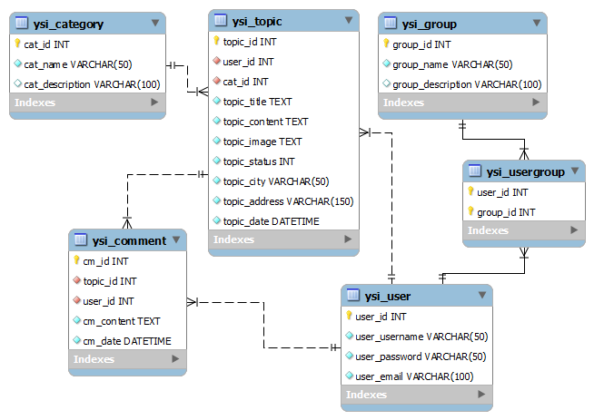
Figure 1: Table Relationship Diagram

Table detail

Table: ysi_category
- The table where will stored list of category of the website
- This included attributes: cat_id, cat_name, cat_description
Table 1: Description detailed of the table ysi_category
Attributes | Data Type | Size | Null | Key | Default | Extra
cat_id | INT |  |  | PK | NULL | Auto_increment
cat_name | Varchar | 50 |  |  | NULL
cat_description | Varchar | 100 | YES |  | NULL

Table: ysi_user
- The table where will stored user who use YouSaveIt website
- This included attributes: user_id, user_username, user_password, user_email
Table 2: Description detailed of the table ysi_user
Attributes | Data Type | Size | Null | Key | Default | Extra
user_id | INT |  |  | PK | NULL | Auto_increment
user_username | Varchar | 50 |  |  | NULL
user_password | Varchar | 50 |  |  | NULL
user_email | Varchar | 100 |  |  | NULL

Table: ysi_topic
- This table where will be stored topic within YouSaveIt website
- This included the attributes: topic_id, user_id, cat_id, topic_title, topic_content, topic_image, topic_status, topic_city, topic_address, topic_date
Table 3: Description detailed of the table ysi_topic

Attributes | Data Type | Size | Null | Key | Default | Extra
topic_id | INT |  |  | PK | NULL | Auto_increment
user_id | INT |  |  | FK | NULL | FK → ysi_user.user_id
cat_id | INT |  |  | FK | NULL | FK →  ysi_category.cat_id
topic_title | TEXT |  |  |  | NULL
topic_content | TEXT |  |  |  | NULL
topic_image | TEXT |  |  |  | NULL
topic_status | INT |  |  |  | 0
topic_city | Varchar | 50 |  |  | NULL
topic_address | Varchar | 150 |  |  | NULL
topic_date | datetime |  |  |  | NULL

Table: ysi_comment
- This table where will stored comments for each post
- This included the attributes: cm_id, topic_id, user_id, cm_content, cm_date
Table 4: Description detailed of the table ysi_comment
Attributes | Data Type | Size | Null | Key | Default | Extra
cm_id | INT |  |  | PK | NULL | Auto_increment
user_id | INT |  |  | FK | NULL | FK→ ysi_user.user_id
topic_id | INT |  |  | FK | NULL | FK→ ysi_topic.topic_id
cm_content | TEXT |  |  |  | NULL
cm_date | Datetime |  |  |  | NULL

Table ysi_group
- This table where will stored list of group of website
- This included the attributes: group_id, group_name, group_description

Table 5: Description detailed of the table ysi_group
Attributes | Data Type | Size | Null | Key | Default | Extra
group_id | INT |  |  | PK | NULL | Auto_increment
group_name | Varchar | 50 |  |  | NULL
group_description | Varchar | 100 | YES |  | NULL

Table: ysi_group
- This table where will store the relationship between group and user
- This included attributes: user_id, group_id
Table 6: Description detailed of the table ysi_usergroup
Attributes | Data Type | Size | Null | Key | Default | Extra
user_id | INT |  |  | PK/FK | NULL | FK → ysi_user.user_id
group_id | INT |  |  | PK/FK | NULL | FK → ysi_group.group_id

Appendix A: Approval
Prepared by | Signature | Date
Tran Cong Binh
K16CMU-TTT
Approved by | Signature | Date
Tran Kim Sanh
Mentor
Duy Tan University

Nguyen Trinh Trung Duong
Mentor
Duy Tan University

